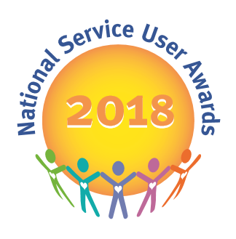
National Service User Awards
Nomination Form

The deadline for applications is: Friday 24th November 2017

The judging day will take place on 3rd January 2018 in central Birmingham- successful applicants will be notified by the 7th December and invited to attend both the Judging Day and the ceremony on 12th April 2018 at RICOH Arena, Coventry

Applicant Name:
Ward Name:
Hospital/Unit:
(Full Address including Postcode)

Please note the information above will not be shared with the events team but will just be used for the purpose of sending outcome of application letters. All applications will be destroyed as confidential waste after review.

Name of Staff Member supporting application
Phone number:
Email Address:

For NSUA use only:

Judging Panel Code No:

For NSUA use only:

Judging Panel Code No:

Why do you apply for the post of Service User Judge?
Can you tell us about any experience you have of being involved in service user led projects in your hospital?

Can you tell us about any relevant experience or achievements that may help you in your role as a judge?

Is there anything else you would like to tell the Service User Events Team to support your application for the post of Service User Judge?

If you wish to post your application please send to:
National Service User Awards , c/o Louise Bannister, Cygnet Hospital Derby, 100 City Gate, London Road, Derby, DE24 8WZ

Secure Email Address for applications:
louise.bannister1@nhs.net

Safe Haven Fax:
01332 292974 – PLEASE ENSURE MARKED FOR THE ATTENTION OF LOUISE BANNISTER

