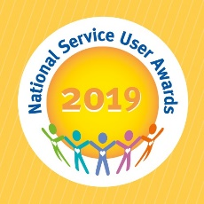
National Service User Awards
Nomination Form
Please return this completed form to events@cygnethealth.co.uk
The deadline for entries is: Friday 25th January

PLEASE DO NOT include any service user identifiable information on this form as the email address is not secure and nominations need to be anonymous for the shortlisting process.

The judging day will take place in early February 2019 - successfully shortlisted finalists will be notified by the end of January and invited to attend the ceremony in May 2019.

Ward/ Service Name:
Hospital/Unit:
Organisation/Company/Trust Name:
Submitted by | Name:  Role:

Nomination category – please tick below as appropriate for your entry:

- Community and Education Projects
- Raising Mental Health Awareness
- Recovery and the Arts
- Health and Wellbeing
- Outstanding Service User Involvement

Name/ Title of Initiative: (maximum 10 words)
Your reference:
Your reference should not include any service user identifiable information. This reference is to help you to identify the nomination if shortlisted, where you / your service have submitted multiple entries.

Person to be contacted in the event of a successful nomination:
Phone number:
Email Address:

Brief summary of initiative in no more than 50 words
(if successful this will be printed in the Awards programme, so 50 words is the strict limit)
Full overview of project (no word limit)
Please consider the following in your response:

- Has this project been led by service users
- How involved service users have been in the project please give examples
- What impact the project has had on service users and the service as a whole
- Can this project have a long lasting effect
- How original is the project
- Why was the project started
- How easy would it be for service users to copy this project
Comments from service users involved in the project or any other additional information:
If you wish to include any supporting information / evidence please include as an email attachment, or send via post, clearly labelled with your entry name to:
NSUA, c/o Louise Bannister, Cygnet Hospital Derby, 100 City Gate, London Road, Derby, DE24 8WZ

